New Horizons for Primary Schools

Computer Tutorials for Teachers

Module #2
Creating PowerPoint Presentations

New Horizons for Primary Schools,
Educational Technology Intervention
Ministry of Education, Youth & Culture,
Caenwood Centre, 37 Arnold Road, Kingston 4. Jamaica.
Tel/Fax: (876) 967-5192, email: nhorizons@cwjamaica.com
Dear Colleagues,
It is with pleasure that the New Horizons for Primary Schools Educational Technology Team brings you the 2nd Module in the series of Computer Tutorials for Teachers. In Module #1 we introduced new users to the computer and to the “Paint” programme which was used to create graphics, while learning to use the mouse. Participants imported the graphics into a “Word Document” and learned to format text and checked spelling errors, among other things. In this new module, we will build on those skills to create a PowerPoint Presentation.
PowerPoint is an application that allows you to build, print, and deliver presentations or slide shows (a "slide" is what PowerPoint calls each screen of information), as there are several options for the delivery of a presentation, but you only have to develop it once. You can print slides, handouts, note pages or deliver an on-screen presentation. However, it is the on-screen presentation that allows you to use the full range of PowerPoint's features.
As you develop a PowerPoint Presentation, it is important to remember that you should not try to include every piece of information you wish to deliver. PowerPoint slides should contain brief, concise, descriptive phrases that will help you remember what you want to present and to serve as a reminder for your audience. As a rule, do not use more than six (6) lines of text on a slide and aim to balance your graphics with text to ensure that the graphics do not over-power the text.
PowerPoint is a great tool to introduce lessons and to pique your students’ interest in the topic you are about to teach.
Have a great time exploring this new tool!

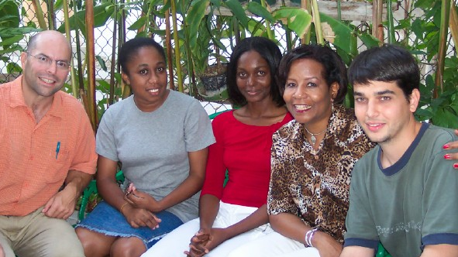
With best wishes,
Jean Beaumont
Educational Technology Specialist
New Horizons for Primary Schools NHP Educational Technology Team

Table of Contents:

Creating a PowerPoint Presentation……………..….…………………………… Page 4

Let’s begin
Adding images from Clipart
Adding new slides

Adding Placeholders.………………………………………………………………… Page 5

Adding Placeholders
PowerPoint views

Editing Your PowerPoint Presentation ……………..……………… ………… Page 6
Deleting Slides
Moving Slides
Applying Design Templates
Adding Textboxes

Formatting Text ……………………………………………….………………… Page 7

Spelling
Saving

Running The Show …………………………………………………………………. Page 8

Printing

An Assessment Rubric ………………………………..................................... Page 9
Creating a PowerPoint Presentation

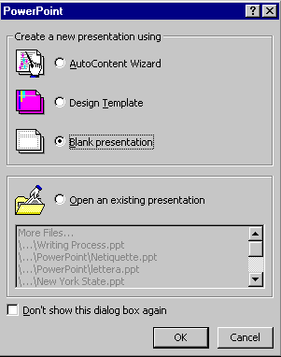
Let’s begin:
One way to start your presentation is to start from scratch. In this way you are starting out with a blank presentation. You can then design your own background choices. You would not be using a template design. Please follow these steps to start a presentation from scratch:
- Open up PowerPoint.
- A PowerPoint dialog box will open.
- Click on the radio button that says blank presentation.
- Click OK.
- Your new presentation will open. Choose your slide layout and click OK.
- Think of a topic that you would teach, such as “Shapes
Around Us”, or “My Teeth” or any topic of your choice.
- You can now start working on the presentation you would like to use for this show.

Adding Images From Clipart:
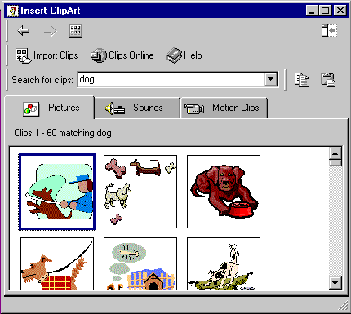
One task you will be performing often would be to add images to your page. You can bring in images that you have saved, or you can go to “Paint” to create your own image, or you can use Microsoft's Clip Gallery which has thousands of images, photos, and animations. It is also searchable making it easier to find the type of image you want to use. To use the clip gallery follow these steps:
- Go to Insert on the menu bar and choose Picture and then Clip Art or you can click on the Clip Gallery icon from the drawing toolbar.
- The Clip Gallery will open.
- Either click on the category you want to look through or type in a keyword for what you are looking for and hit enter.
- The images will appear. When you find the one you like click on it and click on the insert icon.
- You can at this point add additional images or if you are done close the clip gallery window and your image will be placed on your slide.
Adding New Slides:
When you are working on your presentation you will often need to add new slides. Please follow these steps to add a new slide to your presentation:
- While in slide view or normal view click on the new slide icon from the standard toolbar. or
- Go to Insert on the menu bar and choose new slide or click on Control + M. You can also click on the drop down from the common tasks menu bar found on the formatting toolbar and choose new slide.
- The Slide layout dialog box will open.
- Choose the slide layout that best fits the slide you are adding.
- Click on OK and your new slide will be added.
Adding Placeholders:
A quick way to add your text and have it automatically formatted is to add a placeholder. These work great for your titles and subtitles. That way each slide will have a consistency in formatting. To add a placeholder, follow these steps:
- Select “New Slide” from your Insert Menu.
- Click on the down arrow for Common Tasks and choose Slide layout.
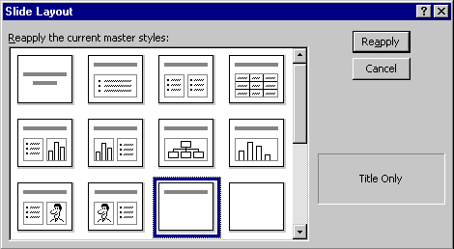
- Click on Apply or Reapply.
- The placeholder will appear. Click inside and start typing. The placeholder's formatting is preset if you are using a design template.

PowerPoint Views:
There are six different views found in PowerPoint. The default is the Normal view. The six views and what they are best used for are shown below.
Normal View | Tri Pane View. You can view notes, outline and your slide all at once.
Slide View | Best used when working on your slides individually. The majority of the screen space is for your slide for easier viewing.
Slide Sorter View | Allows you to view all of your slides at once. Great for moving slides around and deleting or just looking at the flow of your show.
Outline View | Best for working on adding your text for the show. Work in an outline format.
Notes Page View | View a small image of the slide along with space to write your speaker notes.
Slide Show | This is for previewing and actually running the show. The slides will be full screen.
Please follow these steps to change your views:
- Click on the view button on the bottom left hand side of the PowerPoint screen. or
- Go to View on the menu bar and choose the best view to suit your needs.
Deleting Slides:
There are a few ways to delete slides. If you want to delete one slide and you are in normal or slide view follow these steps:
- With the slide open go to Edit on the menu bar and choose delete slide.
- If you have a few slides to delete then you may be better off to delete them in slide sorter view. Get in slide sorter view and follow these steps:
- Click on the slide you want to delete and hold the shift key down while you click on the other slides you want to delete.
- Click on the delete or backspace key and the slides will be deleted.
Moving Slides:
You may find that as you or your students are working on your presentation you may need to move the slide order around. To best do this you should be in the slide sorter view. Once in that view follow these steps:
- Click on the slide that you want to move and hold the mouse button down while you move the slide to the desired location. You will see a vertical bar as you move the slides. When the bar is in front of the slide where you want to position your slide release the mouse button and the slides will be moved to the new position.
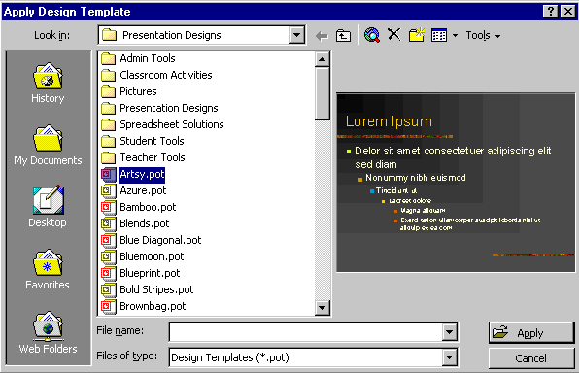
Applying Design Templates:
If you are working on your presentation and at any given time you decide that you would like to apply a design template or change the one you are currently using, follow these steps:
- Right click on the slide you are working on in either the slide view or normal view.
- Click on Apply Design Template. (You can also just click on the down arrow for common tasks and choose Apply Design Template.)
- Click on the design you would like to use and click on the Apply button.
- Your new design will be applied.

Adding Textboxes:
One way to add text to your slide is to add a text box. You will then have to format the text to the desired type. To add a text box follow these steps:
- Click on the text box icon found on the drawing toolbar.
- Click and drag the box in the desired location.
- Type your text.
- Click outside of the box and the lines will disappear.
- To edit the text just click inside the box and make your corrections just as you would with a word processor.
Formatting Text:
There are a couple of different ways to format your text once you type it in. You can either use the menu bar or the Formatting toolbar. To format your text to change things like font, color, style, size etc. follow these steps:
- Select your text by either highlighting it or click on the diagonal lines that surround the text so that it turns to little dots. When you do this any formatting you add will affect everything in the box.
- Using the formatting toolbar choose the formatting that you want to add from the standard toolbar. There are buttons and drop downs for font, size, style, and alignment.
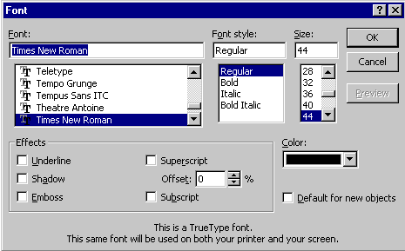
- You can also go to Format on the menu bar and choose font. The font dialog box will open. Make your changes within the dialog box.
- Click OK and your changes will occur.

Spelling:
One very important step in working with PowerPoint is to make sure you perform a spell check on your presentation. You should also proofread it as well. It can be quite embarrassing to find mistakes while you are presenting. To run a spell check, please follow these steps:
- With your presentation open click on the spelling icon from the standard toolbar.
- You can also go to Tools + Spelling or hit F7. A spell check will be run on your show.
- When typing in PowerPoint if you get a red squiggly line under your text that is an indication that your word may be incorrectly spelled. You can right-click on the word and choose one of the words listed or choose ignore if the word was spelled correctly.
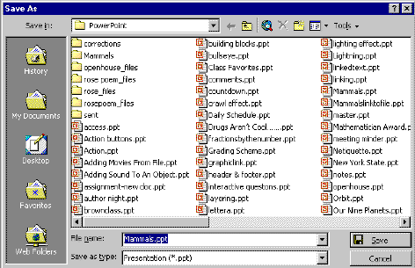
Saving:
You should periodically save your show as you are working. I like to start out by saving my show and then hitting the save icon every five or ten minutes as I work. Please follow these steps to save your presentation:
- If it is the first time you are saving your show go to File on the menu bar and choose Save As.
- Choose the location for saving your file and give your file a name.
- Click on Save.
- If you had saved your show before, you can click on the save icon from the standard toolbar of File to Save.
Running The Show:
To run your show, check it out, or when it is for the real presentation follow these steps:
- If you want to start at the beginning of your presentation then go to Slide Show from the menu bar and choose View Show or hit F5.
- If you want to begin looking at your show starting at the slide you currently have open in normal or slide view then click on the slide show icon from the views icon.
Printing:
You can print out your presentation in different formats. All of the variations of the printing types can be found in the print dialog box. Listed in the table below are the types of printing you can do. To print your presentation please follow these steps:
- Go to File on the menu bar and choose Print.
- The Print dialog box will appear. It may look different than the one displayed here. The dialog box varies depending on your particular type of printer. You should have basically the same options however.
- Choose what you want to print, all slides, particular slides, or the current slide.
- Enter the number of copies you want to print. Check if you want them collated.
- Choose what you want to print: slides, handouts, notes pages, or outline view.
- Click on OK.

Printing Choices
Slides | Prints out each slide on a full page.
Handouts | Here you have choices for 2,3,4,6,or 9 slides per page. If you choose 3 then your slides will also have lines to the write for note taking purposes. You also have a choice to order then on the page horizontally or vertically.
Note Pages | Prints out one small version of each slide per page with your notes section on the bottom of the page.
Outline View | Prints out the outline view of your presentation.

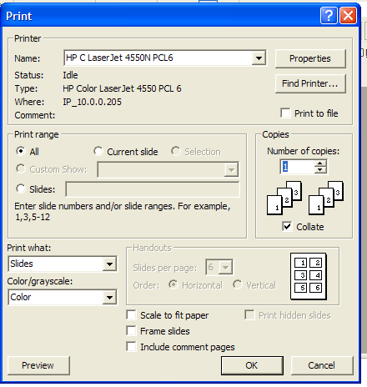
Good luck with your PowerPoint Presentations. On completion of this module you will be able to use this tool to create powerful and exciting lessons that will engage your students and encourage collaborative learning in your classrooms.

Rubrics for PowerPoint Presentation
The following Rubric has been adapted from: http://fno.org/sept00/powerpoints.html#anchor2 and serves as a guide as you develop your PowerPoint Lesson.
In addition to providing examples of good work, we make use of rubrics to clarify our expectations. The following rubrics designed for a national contest outline expectations across more than ten issues:
- Story Board or Planning Sheet
- Organization of Content
- Originality
- Copyright and Documentation
- Format and Platform Transferability
- Subject Knowledge
- Graphical Design
- Mechanics
- Screen Design
- Use of Enhancements
- Teamwork

Assessing Creativity and Originality of Work
1 | 2 | 3 | 4
The presentation is a minimal collection or rehash of other people's ideas, products, images and inventions. There is no evidence of new thought. | The presentation is an extensive collection and rehash of other people's ideas, products, images and inventions. There is no evidence of new thought or inventiveness. | The presentation shows evidence of creativity, originality and inventiveness. While based on an extensive collection of other people's ideas, products, images and inventions, the work extends beyond that collection to offer new insights. | The presentation shows significant evidence of creativity, originality and inventiveness. The majority of the content and many of the ideas are fresh, original, inventive, and based upon logical conclusions and sound research.
For the full text go to http://www2.ncsu.edu/ncsu/cep/midlink/rub.multi.htm

