Computer Tutorials for Teachers

Using Free, Open Source Software

Module 3

New Horizons for Primary Schools,
Educational Technology Intervention
Ministry of Education, Youth & Culture,
Caenwood Centre, 37 Arnold Road, Kingston 4. Jamaica.
Tel/Fax: (876) 967-5192, email: nhorizons@cwjamaica.com

Dear Colleagues,

This module represents the 3rd Module in the series of Computer Tutorials for Teachers. In Module 1, we introduced new users to the computer and to the Paint programme. In this module we focused on developing the basic skills in using the mouse, using Windows, using Microsoft Word and developing simple graphics.

Module 2 introduced presentation software called Microsoft PowerPoint. PowerPoint is an application that allows you to create, print, and lesson deliver presentations or “slideshows”. Using PowerPoint you can develop a professional presentation that can be used again and again in your classrooms.

This third module, “Using Free, Open Source Software,” represents the continuing effort to provide useful tools to create engaging and interesting lessons for children. By using free software, you can continue to improve your computer learning environment without additional costs. And, the software presented in this module is simply a starting point.

The field of free, open source software is growing and provides many opportunities to reduce the overall cost of deploying computers in your schools, as well as becoming involved in the development of the software itself.

Please enjoy this latest installment in Computer Tutorials for Teachers.

With best wishes,

Jean Beaumont

Educational Technology Specialist
New Horizons for Primary Schools
Module Overview

Purpose

Free software provides excellent opportunities for schools to improve their learning environments, leverage computer resources, and maximize their budgets. This module will highlight these opportunities.

Audience

The users of this software may be children, teachers or computer administrators. A basic competence with using the personal computer will be required to install and uninstall programs.

Objectives

- Understand what open source and other kinds of free software are.
- Learn how to install and uninstall software for your school computers.
- Learn about selected free software packages.
- Learn how to integrate free software into your classroom.
Table of Contents

What is Free Software? 5
Different Kinds of Free Software
Open Source
Freeware
Pros and Cons

Finding Free Software and Other Things Free 6
School Tools CD

Installing and Uninstalling Software 6
Know Your Operating System
Windows
Installing
Uninstalling

Selected Applications 8
Letter Learner
Letter Sounds
TuxPaint
TuxMath
TuxType
Typing Tutor
Celestia
OpenOffice
ChildProof

Appendix I: More Free Things 18

What is Free Software?

Software makes your computer work. Typically, when we buy a computer, we are buying software as well as hardware. However, not all software needs to be purchased. A significant number of software packages are available free of charge. Open source software, freeware, charityware and abandonware are free and present opportunities to improve educational environments and save money.

Free software can provide the same features, functions and capabilities as “proprietary software”. And, because they are legal, functional and reliable, free software can be a viable alternative to software you must buy or to making illegal copies.

Depending on your needs and resources, you can mix free software and proprietary software. For example, your computer can run both Microsoft Windows and utilize free software. Further, you can replace all the paid for software on your computer and use a system that is built entirely on free software.

The different kinds of free software are distinguished by the legal contract as to how the software can be modified, distributed and used. Some can be modified and shared but not re-sold. Others are only free if you are an educational institution. Yet others cannot be modified, but can be shared and freely distributed.

Two kinds of free software are described below. The box below has some links for additional readings on free software.

Open source software is available free, includes source code, can be modified and distributed.

Freeware is software that is available free. Such software can sometimes be used by unscrupulous individuals to collect information about you. Usually source code is not made available.

Additional Reading – Defining Different Kinds of Free Software

Definition of Open Source http://www.opensource.org/docs/definition.php
Various Open Source Software Licenses http://www.opensource.org/site_index.php
Abandonware http://www.abandonwarering.com/?Page=FAQ
Charityware http://dictionary.reference.com/search?q=careware
Freeware http://dictionary.reference.com/search?q=freeware
Why use Free Software?
- It’s Free!
- It can do the same things as software you purchase.
- It’s very similar to the software you may already be using.
- It’s legal.

What are the problems in using Free Software?
- It’s different.
- Less technical support. available
- May never change or change slowly.

Finding Free Software and Other Things Free

There are a huge number of sites offering all sorts of free software. In fact, there are so many offerings on the Internet that it is very confusing as to what to use.

Our expectation is that you will begin to develop the skills to find, install and evaluate the appropriateness of software packages for your learning environment.

School Tools CD

An excellent starting point for your investigations into the world of free software is the School Tools CD. The School Tools CD is a compilation of freeware, shareware and open source software. This software has been downloaded and evaluated by computer professionals as having merit for supporting and maintaining computer systems, as well as providing useful educational tools.

All the software that will be reviewed in this class is on the School Tools CD.

Installing and Uninstalling Software

Installing software is easy – usually. Sometimes it is more involved and often be a little different from program to program.

There is no standard way of installing software. The developer of the software decides how they want to install the software, and there can be significant differences.

In order to select and evaluate software, you must know basic information about your system. Identifying which operating system you are using is critical, but pretty simple.
Know Your Operating System

If you are working with a personal computer, you probably have Microsoft Windows. Microsoft Windows uses a graphical user interface. A graphical user interface lets the user interact with a computer system in a highly visual manner, with a minimum of typing

If you have no graphical interface, you are probably using DOS. DOS programs can often run with Windows; however, Windows programs cannot run on DOS computers.

Installing

To install software, you will need a file that can load the program on your computer. The file is often called ‘Setup.exe’. A simple double-click on the setup file is all that is required to start the installation. Usually you must answer a few questions to fully install the software.

Different setup programs ask different questions. You should strive to understand what these options mean and not simply click through the questions. You should also read (or at least skim) the License Agreement.

Look for “ReadMe” files that contain important information about installing, configuring and using the software.

Uninstalling

You should uninstall a program if you are not going to use it. Uninstalling will keep your computer ‘clean and neat’.

In Windows, you should always check the Add and Remove Programs application under Control Panel to uninstall a program. To access this, go to Start | Settings | Control Panel and find the Add and Remove Programs icon. Double-clicking this icon will open up the dialog box that can be used to uninstall.

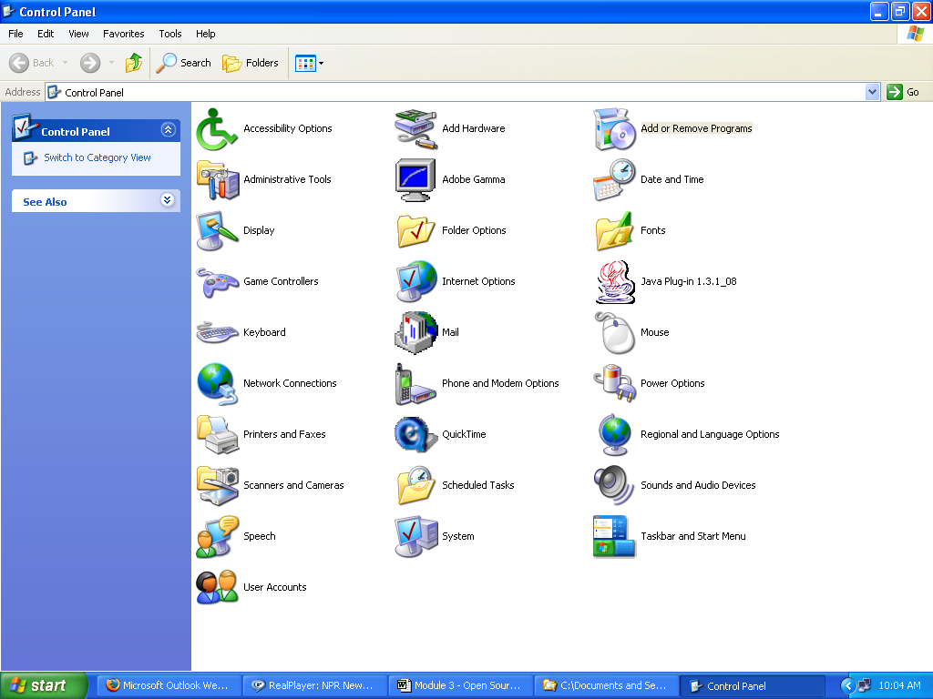

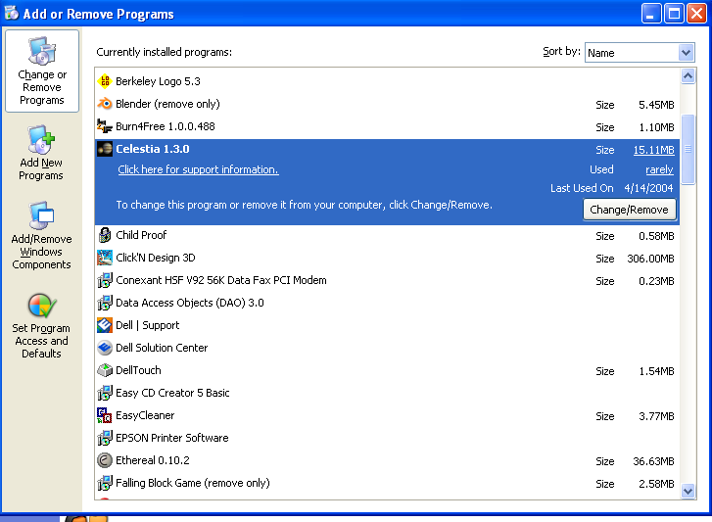

If you do not find the program listed in Add and Remove Programs, then you may just want to delete the folder itself.

Selected Programs

Software | Audience | Description
Letter Learner | Grades 1-3 | Learn about letters
Letter Sounds | Grades 1-3 | Learn about letter sounds
TuxPaint | All Grades | Fun with graphics
TuxMath | All Grades | Fun with Math
TuxType | All Grades | Fun with words
Typing Tutor | All Grades | Learn to touch type
Celestia | Grades 5-6 | Travel thru the universe and learn about the stars
OpenOffice | All Grades | Like Microsoft Office (includes Word Processor, Spreadsheet, Presentation Software)
ChildProof | Teacher | Limits children’s ability to change computer configuration

Letter Learner
Alphabet tutor

General Description
Learn Letters teaches children the 26 letters of the alphabet. Using the shapes the letters have in common, the child is guided as he combines shapes to make the lower case letters of the alphabet.

Program Notes
Press ESC to exit the current level.
The letter shapes need to be precisely maneuvered or they won’t ‘stay’.

Educational Activities
- Reinforce making letters and learning the alphabet.
- Use the different letter shapes to identify colors.
- Have children write the letters out with paper and pencil after ‘building’ the letters within Letter Learner.
- After building the letters, review the alphabet. Sing the alphabet song using the newly constructed alphabet to lead the children.
A - B - C - D - E - F - G - H - I - J - K - L - M - N - O – P - Q - R - S - T - U - V - W - X - Y and Z; Now I know my A - B - C's; Next time won't you sing with me?

Letter Sounds
Let’s listen for those sounds

General Description
Letter Sounds teaches children to pronounce the 26 letters of the alphabet. Using the shapes the letters have in common, the child is guided as he learns the alphabet.

Program Notes
Needs sound card and functioning speakers.

Suggested Educational Activities
- Use Letter Sounds to reinforce learning letters.

TuxPaint
Discover the Artist Within…

General Description
TuxPaint is a fun paint program. While it is like the Paint program on your workstation, TuxPaint has bigger buttons to select from, more features and the ability to add your own Stamps

Suggested Educational Activities
- Use the SHAPES tool to learn about circles, squares and rectangles.
- Use the STAMPS tool to practice counting and to identify other different animals.

TuxMath
Math is for everyone

General Description
Mathematical equations drop from the top of the screen. The child must ‘shoot’ the equation before it reaches the bottom. Basic math equations are used – addition, subtraction, multiplication, and division.

Suggested Educational Activities
- Have a Math Day with one of the activities utilizing TuxMath.

TuxType
I can type and I can spell.

General Description
TuxType is a game where words drop from the top of the screen and must be spelled out using the keyboard before the words come to the bottom. An excellent feature of this software is the ability to add and change words used. This software has been customized with Jamaican words.

Program Notes
Changing the Word List
A selection of Jamaican words are already included. To use these Jamaican words, start TuxType and select Options | Setup Language | Jamaican.

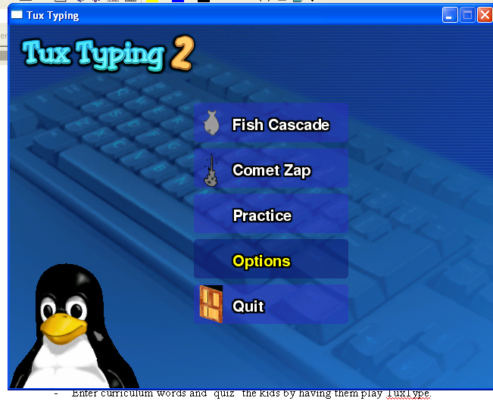

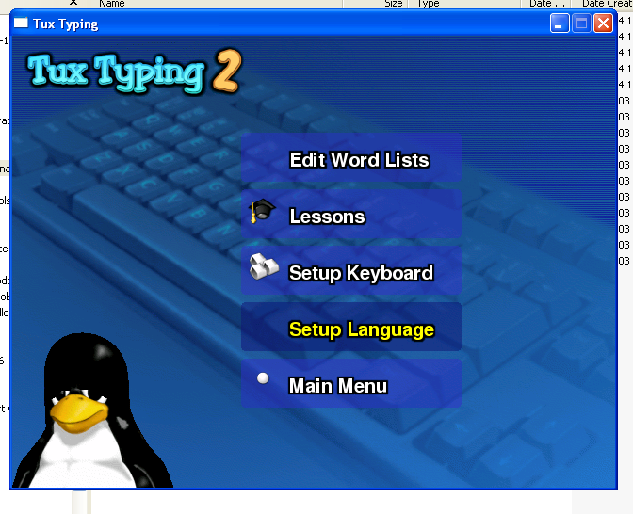
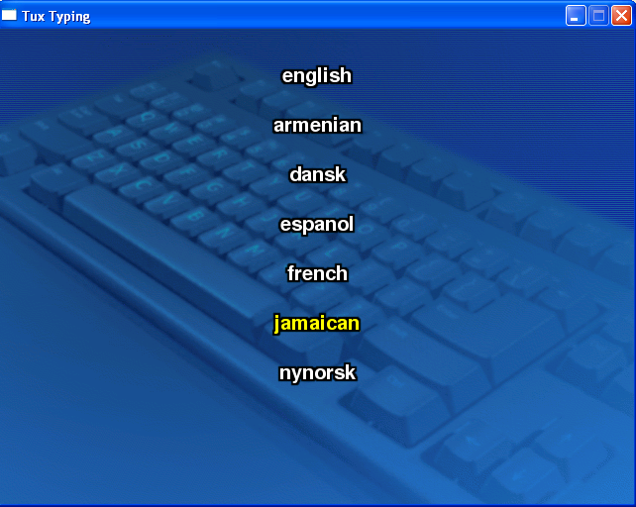

Creating New Word Lists
First, create the list of words and then save the file to the folder called “C:\Program Files\tuxtype2\data\themes\jamaican\words”.

It is easiest to use Notepad to add words. You can also use Microsoft Word or OpenOffice to create the list. If you use Word or a similar package you MUST be sure to use the Save As… feature to save the document as a Text Document.

The first line must be the Name of the word list (eg, Jamaican Long Words). Then, type one word per line. After each word, press Enter or Return. So, your list would look like…
Name of Word List
Parts of a Car
tire
windshield
door
words

When the list is complete, save the document in the appropriate folder. Remember, if you are not using Notepad, you must remember to save the document as a Text File.

Suggested Educational Activities

Enter curriculum words and ‘quiz’ the kids by having them use TuxType with the words from your curriculum. Save the work and use it again next year!

Typing Tutor
I can type

General Description
Learn how to type.

Suggested Educational Activities
- Practice typing to learn the alphabet.
- Use in conjunction with OpenOffice to type a business letter.
- Have a contest to see who can type the most words with the fewest errors.

Celestia
Visit Our Solar System

Description
Celestia is a real-time space simulation that lets you visually experience our universe in stunning three dimensions. It depicts the entire Solar System of planets, moons, asteroids, comets and human spacecraft in vivid detail, and can draw over 2 million stars in real time, positioning them in their proper places in both space and time. It not only draws each space object in full color, it also can illustrate and put into motion their atmospheres, drifting clouds, moving surface shadows, spectacular reflections off of oceans, changing eclipses, speeding comet tails and swirling nebula gas.

While Celestia is a relatively simple program to use, there are enough features and control keys to make the product seem confusing. However, with a small investment of time, you too can learn how to fly through the universe.

The following activities are created for the Grade 6, Social Studies, Term One, Unit One, Planet Earth As Part of the Solar System Activity Plan. By understanding the activities below, you can use Celestia to:

- Define and use the concepts planet, moon, start, orbit, solar system
- Identify the Earth and its relationship to the planets and sun in our solar system
- Describe the shape of the Earth
- Identify the path along which a planet moves

Further, there are many additional add-ons for Celestia and activities that have been created for older students.

To learn more about Celestia and space, see:
- http://www.shatters.net/celestia/index.html

Suggested Educational Activities

Run the Demo
Press D
Press ESC to cancel

See the Solar System
Navigate to the Sun (called “Sol”)
Press H to Select the Sun + Press G to go to the Sun + Press F to follow the Sun
Turn On/Turn Off Planet Orbits - Press O

Turn On/Turn Off Planet Labels - Press P
Move away from Solar System to get Full perspective
Use mouse to move farther from or closer to the sun –
Left Mouse + Right Mouse + Drag
Use mouse to rotate around system - Right Mouse + Drag
Use mouse to center system - Left Mouse + Drag
Make things go faster or slower - Use L to go faster; Use K to go slower
(10,000x or 100,000x are good values to try)

Go to a Planet or Moon
Select the planet - Press ENTER + Type in Planet Name
Go to the planet - Press G
- OR -
Select Navigation - Select “Solar System Browser”
Select the Planet, Moon or Satellite
Click “Center” or “Go To”

See Planetary Orbits
Turn On/Turn Off Planet Orbits - Press O
See Names of Things
Turn On/Turn Off Planet Names - Press P
Turn On/Turn Off constellation labels - Press =
Turn On/Turn Off star labels - Press B
Turn On/Turn Off galaxy labels- Press E
Turn On/Turn Off moon labels - Press M
Turn On/Turn Off asteroid & comet labels - Press W
Turn On/Turn Off spacecraft labels - Press N

Watch the Moon Revolve Around the Earth
Go to Earth - Press ENTER and type “Earth” + Press G to go to Earth + Press F to follow the Earth
View the Moon - Press M to Turn On/Turn Off Moon Labels
View the Space Station/Hbble - Press N to Turn On/Turn Off Spacecraft Labels
Move away from the Earth to get Full perspective
Use mouse to move away from sun - Left Mouse + Right Mouse + Drag
Use mouse to rotate around system - Right Mouse + Drag
Use mouse to center system - Left Mouse + Drag
Make things go faster or slower - Use L to go faster; Use K to go slower
(10,000x or 100,000x are good values to try)

Summary of Mouse and Keyboard Controls for Celestia

Mouse Functions
Left drag - orient camera
Right drag - orbit the selected object
Wheel - adjust distance to selection
Right + Left drag - adjust distance to selection
Ctrl + Left drag - adjust distance to selection
Shift + Left drag - change field of view (e.g. =>telescopic view)
Wheel (middle button) click - Turn On/Turn Off field of view between 45 degrees and the previous field (e.g. telescopic view)
Left – click - select object
Left double click - center selection
Right – click - bring up context menu
Keyboard Commands
Navigation
H - Select the sun (Home)
C - Center on selected object
G - Goto selected object
F - Follow selected object
Y - Orbit the selected object at a rate synced to its rotation
" - Chase selected object (orientation is based on selection's velocity)
T - Track selected object (keep selected object centered in view)
HOME - Move closer to object
* - Look back
END - Move farther from object
ESC - Cancel motion or script
Left/Right Arrows - Roll Camera
Up / Down Arrows - Change Camera Pitch
1-9 - Select planets around nearby sun
Time
Space - stop time
L - Time 10x faster
K - Time 10x slower
J - Reverse time
! - Set time to now
? - Display light-travel delay between observer and selected object
- - Subtract light-travel delay from
- current simulation time
Labels
= - Turn On/Turn Off constellation labels
B - Turn On/Turn Off star labels
E - Turn On/Turn Off galaxy labels
M - Turn On/Turn Off moon labels
W - Turn On/Turn Off asteroid & comet labels
N - Turn On/Turn Off spacecraft labels
P - Turn On/Turn Off planet labels
V - Turn On/Turn Off verbosity of info text
Options
I - Turn On/Turn Off cloud textures
U - Turn On/Turn Off galaxy rendering
O - Turn On/Turn Off planet orbits
/ - Turn On/Turn Off constellation diagrams
; - Show an earth-based equatorial coordinate sphere
[ - If autoMag OFF: Decrease limiting magnitude (fewer stars visible), If autoMag ON : Decrease limiting magnitude at 45 deg field of view
] - If autoMag OFF: Increase limiting magnitude (more stars visible), If autoMag ON : Increase limiting magnitude at 45 deg field of view
{ - Decrease ambient illumination
} - Increase ambient illumination
, - Narrow field of view
. - Widen field of view
Backspace - Cancel current selection
Ctrl+A - Turn On/Turn Off atmospheres
Ctrl+B - Turn On/Turn Off constellation boundaries
Ctrl+E - Turn On/Turn Off eclipse shadow rendering
Ctrl+L - Turn On/Turn Off night side planet maps (light pollution)
Ctrl+S - Turn On/Turn Off rendering stars as points
- (otherwise, they're textures)
Ctrl+P - Turn On/Turn Off per-pixel lighting (if
- supported)
Ctrl+T - Turn On/Turn Off rendering of comet tails
Ctrl+V - Turn On/Turn Off vertex programs (if
- supported)
Ctrl+W - Turn On/Turn Off wireframe mode
Ctrl+X - Turn On/Turn Off antialias lines
Ctrl+Y - Turn On/Turn Off autoMag = auto adaptation of
- star visibility to field of view
r R - lower or raise texture resolution
Multiview
Ctrl+R - Split view vertically
Ctrl+U - Split view horizontally
TAB - Cycle active view
DEL - Delete active view
Ctrl+D - Delete all views except active one
Spaceflight
F1 - Stop
F2 - Set velocity to 1 km/s
F3 - Set velocity to 1,000 km/s
F4 - Set velocity to speed of light
F5 - Set velocity to 10x the speed of light.
F6 - Set velocity to 1 AU/s
F7 - Set velocity to 1 ly/s
A - Increase velocity
Z - Decrease velocity
Q - Reverse direction
X - Set movement direction toward
- center of screen
Number pad
4 - Yaw left
6 - Yaw right
8 - Pitch down
2 - Pitch up
7 - Roll left
9 - Roll right
5 - Stop rotation

OpenOffice
A Complete Office and it’s Free!

General Description
OpenOffice is a productivity suite like Microsoft Office that includes a word processor, spreadsheet and presentation software. It is provides the same basic features as Microsoft Office. Unlike Microsoft Office, it is free, requires no license key and can be downloaded again if you lose your installation CDs.

Suggested Educational Activities
- Learn to write a business letter
- Develop a presentation
- Make word bingo using the word processor and play the game during class.

ChildProof
Protect your computer!

General Description
This application is not an educational program, but a program that can help keep the children from changing the setup or configuration of the computer. It is an excellent addition to any computer in a school.

To use ChildProof, start the setup program and install the software.

Program Notes
Customize the Screen
Change if you change the BMP file, you can customize the startup screen to use your school name. Use MSPaint to modify C:\Program Files\Child Proof\Background.bmp.
Changing Options
Go to the Global Options menu item by pressing CTRL + O.

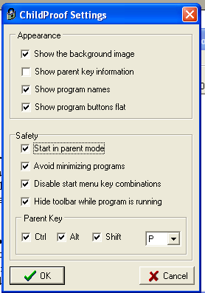
Uncheck this option to prevent display of exit keys
Check this option to start in Parent mode

Automatic Startup
Place a shortcut of ChildProof in your Startup group.
See http://www.ehow.com/how_8461_launch-program-automatically.html

Appendix I: More Free Things

Sources for Free Software

As mentioned, there are many, many places offering free software. A few good sites will be mentioned. And, there are many websites that will waste your time. Your experience will be a good guide and be sure to share your favorite places with your colleagues.

- SourceForge – http://sf.net
- SchoolForge - http://www.schoolforge.net/
- SEUL - http://richtech.ca/seul/
- Mathematics Archive WWW Server - http://archives.math.utk.edu/index.html
- In2Edu - http://www.in2edu.com/edulinks/
- Mark Ovemar’s Page - http://www.cs.uu.nl/people/markov/kids/index.html
- The Abandonware Ring - http://www.abandonwarering.com/?Page=FAQ

Sources for Free Technical Information

The Internet also has a number of places to learn about computers, programming, the Internet, web design and so on. A few of these sites are:

- www.comptechdoc.org
- www.freeskills.com
- www.techtutorials.com
- www.pcnineoneone.com
- www.onecomputerguy.com

